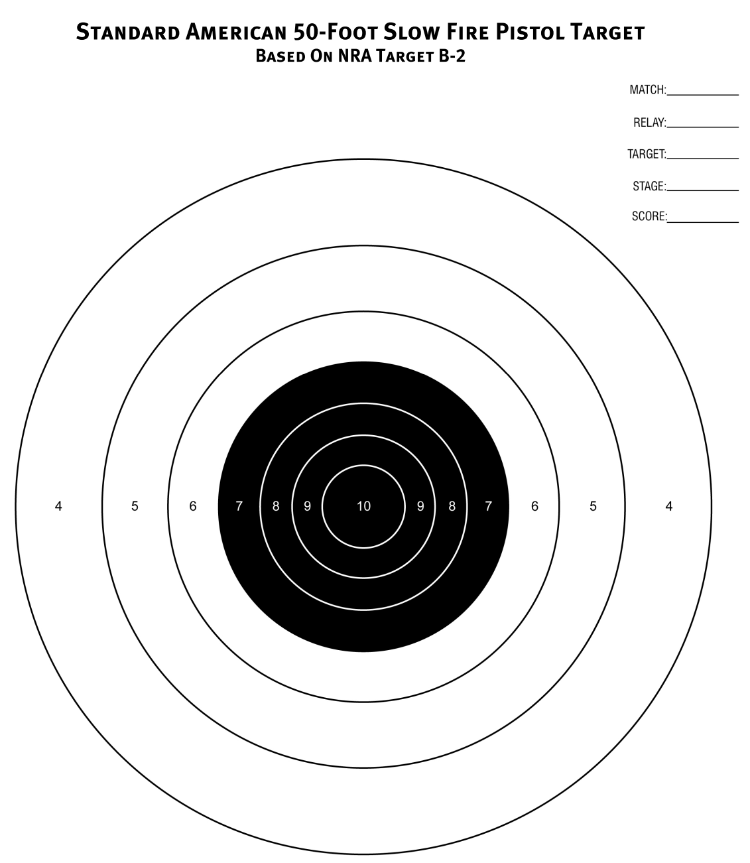
ACCURACY PISTOL LEAGUE TARGET TWO (2) Full Name: _____________________________
Pistol 38/9/40 Week Match #: _______ Target String #: ___________

16.5 Yards – Green Line

